**LAB 07**

**Samad Amir**

**21k-3873**

**Task1:**

**Code:**

<?php

$integerVariable = 10;

$floatVariable = 5.6;

$stringVariable = "Samad Amir";

$booleanVariable = true;

$arrayVariable = array(1, 2, 3, 4, 5);

echo "Looping through an integer:\n";

for ($i = 0; $i < $integerVariable; $i++) {

echo "$i ";

}

echo "\n\n";

echo "Looping through a float:\n";

for ($i = 0; $i < $floatVariable; $i += 0.5) {

echo "$i ";

}

echo "\n\n";

echo "Looping through a string :\n";

for ($i = 0; $i < strlen($stringVariable); $i++) {

echo $stringVariable[$i] . " ";

}

echo "\n\n";

echo "Looping through a boolean:\n";

for ($i = 0; $i < 2; $i++) {

echo $booleanVariable ? "true " : "false ";

}

echo "\n\n";

echo "Looping through an array:\n";

foreach ($arrayVariable as $value) {

echo "$value ";

}

echo "\n\n";

?>

**Output:**

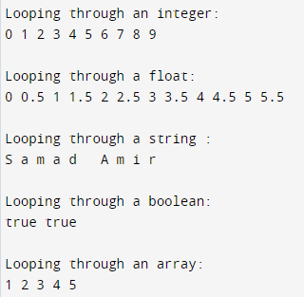

**Task02:**

<?php

function operatorDemo() {

// Assignment operators

$a = 10;

$b = 5;

// Comparison operators

$result1 = ($a == $b); // false

$result2 = ($a != $b); // true

$result3 = ($a < $b); // false

$result4 = ($a > $b); // true

$result5 = ($a <= $b); // false

$result6 = ($a >= $b); // true

// Increment/Decrement operators

$c = 10;

$c++; // Increment

$d = 5;

$d--; // Decrement

// Logical operators

$bool1 = true;

$bool2 = false;

$logicalAnd = $bool1 && $bool2; // false

$logicalOr = $bool1 || $bool2; // true

$logicalNot = !$bool1; // false

// String operators

$str1 = "Hello";

$str2 = "World";

$concatenatedStr = $str1 . $str2; // "HelloWorld"

// Array operators

$arr1 = array(1, 2, 3);

$arr2 = array(4, 5, 6);

$concatenatedArr = $arr1 + $arr2; // [1, 2, 3, 4, 5, 6]

// Conditional assignment operators

$x = 10;

$y = ($x > 5) ? "greater than 5" : "less than or equal to 5"; // "greater than 5"

// Arithmetic operators

$operand1 = 10;

$operand2 = 3;

$addition = $operand1 + $operand2; // 13

$subtraction = $operand1 - $operand2; // 7

$multiplication = $operand1 * $operand2; // 30

$division = $operand1 / $operand2; // 3.333...

$modulus = $operand1 % $operand2; // 1

echo "Comparison operators:\n";

echo "\$result1: $result1, \$result2: $result2, \$result3: $result3, \$result4: $result4, \$result5: $result5, \$result6: $result6\n";

echo "\nIncrement/Decrement operators:\n";

echo "\$c: $c, \$d: $d\n";

echo "\nLogical operators:\n";

echo "\$logicalAnd: $logicalAnd, \$logicalOr: $logicalOr, \$logicalNot: $logicalNot\n";

echo "\nString operators:\n";

echo "\$concatenatedStr: $concatenatedStr\n";

echo "\nArray operators:\n";

print_r($concatenatedArr);

echo "\nConditional assignment operators:\n";

echo "\$y: $y\n";

echo "\nArithmetic operators:\n";

echo "\$addition: $addition, \$subtraction: $subtraction, \$multiplication: $multiplication, \$division: $division, \$modulus: $modulus\n";

}

operatorDemo();

?>

Output:

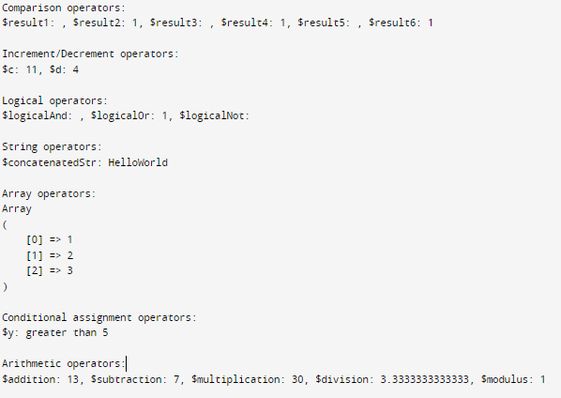

**Task03:**

**Code:**

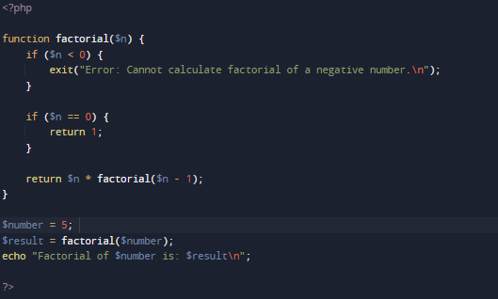

**Output:**



**Task04:**

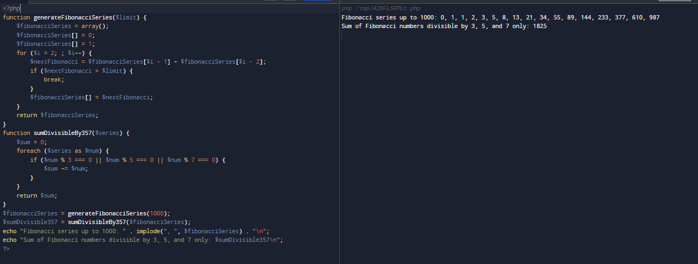

**Both For loop and While loop uses O(n) so it comes to personal preference which to use , the performance of both remains same.**

**Task05:**

**Code:**

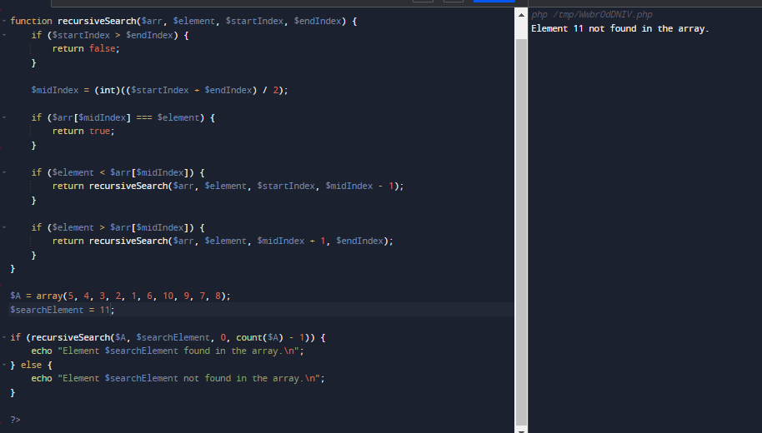

**Task06:**

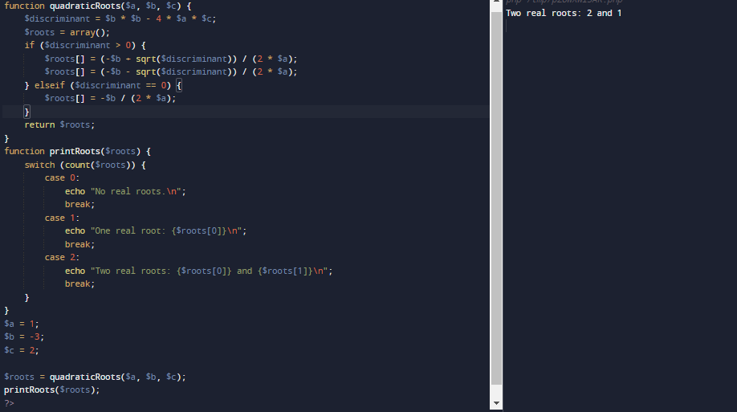

**Task07:**

**Code:**

<!DOCTYPE html>

<html>

<head>

<title>Signup Form</title>

</head>

<body>

<h2>Signup Form</h2>

<form method="post" action="<?php echo $_SERVER['PHP_SELF']; ?>">

<label for="username">Username:</label>

<input type="text" id="username" name="username" required><br><br>

<label for="email">Email:</label>

<input type="email" id="email" name="email" required><br><br>

<label for="password">Password:</label>

<input type="password" id="password" name="password" required><br><br>

<input type="submit" value="Submit">

</form>

<?php

if ($_SERVER["REQUEST_METHOD"] == "POST") {

$username = $_POST['username'];

$email = $_POST['email'];

$password = $_POST['password'];

echo "<h2>Submitted Data:</h2>";

echo "Username: $username<br>";

echo "Email: $email<br>";

}

?>

</body>

</html>

**Output:**

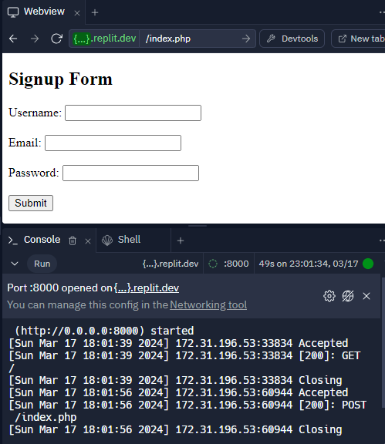

**Task08:**

**Code:**

<!DOCTYPE html>

<html>

<head>

<title>Lab Manual Example</title>

</head>

<body>

<h2>Lab Manual Example</h2>

<h3>1. Simple Arithmetic Operations:</h3>

<?php

// Simple arithmetic operations

$num1 = 10;

$num2 = 5;

echo "Addition: " . ($num1 + $num2) . "<br>";

echo "Subtraction: " . ($num1 - $num2) . "<br>";

echo "Multiplication: " . ($num1 * $num2) . "<br>";

echo "Division: " . ($num1 / $num2) . "<br>";

echo "Modulus: " . ($num1 % $num2) . "<br>";

?>

<h3>2. Conditional Statements:</h3>

<?php

// Conditional Statements

$x = 10;

$y = 5;

if ($x > $y) {

echo "$x is greater than $y<br>";

} elseif ($x < $y) {

echo "$x is less than $y<br>";

} else {

echo "$x is equal to $y<br>";

}

?>

<h3>3. Looping:</h3>

<?php

// Looping

echo "Using for loop:<br>";

for ($i = 1; $i <= 5; $i++) {

echo "Iteration $i<br>";

}

echo "<br>Using while loop:<br>";

$j = 1;

while ($j <= 5) {

echo "Iteration $j<br>";

$j++;

}

?>

<h3>4. Functions:</h3>

<?php

// Functions

function square($num) {

return $num * $num;

}

$number = 5;

echo "Square of $number is: " . square($number) . "<br>";

?>

<h3>5. Signup Form (Using GET and POST methods):</h3>

<h4>GET Method:</h4>

<form method="get" action="<?php echo $_SERVER['PHP_SELF']; ?>">

<label for="name">Name:</label>

<input type="text" id="name" name="name" required><br><br>

<input type="submit" value="Submit">

</form>

<?php

// Process form data using GET method

if (isset($_GET['name'])) {

$name = $_GET['name'];

echo "<p>Welcome, $name (Using GET method).</p>";

}

?>

<h4>POST Method:</h4>

<form method="post" action="<?php echo $_SERVER['PHP_SELF']; ?>">

<label for="username">Username:</label>

<input type="text" id="username" name="username" required><br><br>

<label for="email">Email:</label>

<input type="email" id="email" name="email" required><br><br>

<label for="password">Password:</label>

<input type="password" id="password" name="password" required><br><br>

<input type="submit" value="Submit">

</form>

<?php

// Process form data using POST method

if ($_SERVER["REQUEST_METHOD"] == "POST") {

$username = $_POST['username'];

$email = $_POST['email'];

echo "<p>Thank you, $username! Your email is: $email (Using POST method).</p>";

}

?>

</body>

</html>

**Output:**

